REcpetion
Literacy

Comprehension
Children will know the logos for local supermarkets.
Children will read and re-read a selection of books to engage in conversations about the story, develop understanding and learn new vocabulary.
Children will know a range of signs including bus stop, parking, and stop.
Children will read and re-read a selection of books to engage in conversations about the story, develop understanding and learn new vocabulary.

Word Reading (Phase 1 Phonics)
Children will spot and suggest rhymes.
Children will clap syllables in a word.

Writing (Physical)
Children will know how to draw horizontal lines.
Children will know how to draw vertical lines.

Core Texts

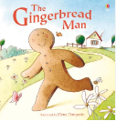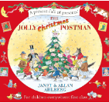

Understanding the World

Past and Present
Children will know they were a baby.
Children will know about Remembrance Day and Bonfire Night.
People, Culture and Communities
Children will be able to identify the daily weather.
Children will be able to take care of our classroom environment.
Children will know that a globe/world map represents the world.
Children can say who is special to them in their family.
Children can explain how they feel when they receive a present.
The Natural World
Children will know the names of body parts.
Children will know how materials change when cooking, cooling and heating.
Children will make collections of natural materials to investigate.
Technology
Children will know how to ask an adult to take a photo on the iPad
Children will know how to use the Interactive white board.

Nursery
Autumn Term Overview
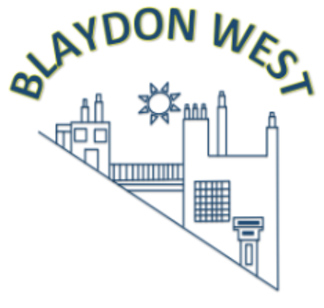
Our Themes:
Autumn 1 - Marvellous Me
Autumn 2 - Let’s Celebrate

Maths
Number
Children will subitise 2.
Children will count to in correspondence to 5.
Children will recognise numerals 0-5.

Numerical Patterns

Children will identify colours.
Children will sort by colour, size and object.
Children will identify patterns around them such as stripes on clothes.


[
Physical Development
Gross Motor
Children will know how to use wheelie boards.
Children will know how to ride a tricycle.
Introduction to PE Unit 1
Soft play
Fundamentals Unit 1
Climbing frame
Fine Motor
Children will explore large mark making to develop cross the mid-line movements.
Children will know how to use tweezers to pick up pom poms/loose parts.

Should you require any further information, please email-nursery@blaydonwest.gateshead.sch.uk?

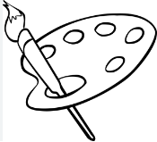
Expressive Arts and Design
Creating with Materials
Children will use pencils/mark making equipment to draw freely.
Children can manipulate play dough.
Children to recognise and name colours.
Children will paint on a flat surface and outdoors.
Children to use a variety of tools to apply paint.
Children to explore construction materials.
Children will learn a selection of nursery rhymes.

Personal, Social and Emotional Development
Self-Regulation
Children will separate from main carer to come into nursery.
Children will know that adults can help them in nursery.
Managing Self
Children will know the nursery rules and routines – team stop, washing hands when entering nursery and before eating.
Children will know how to look after resources – tidying up, picking things up, and lids on pens.
Building Relationships
Children will play alongside each other.
Children will know how to play partner games.

Communication and Language

Listening, Attention and Understanding
Children will point out objects/pictures in a story.
Children will understand ‘what’ questions, using colourful semantics.

Speaking
Children will know and retell the story ‘The Gingerbread Man.’
Children to know and retell the story of The Jolly Christmas Postman.
Children will know and use language linked to their All About Me and Let’s Celebrate topics and texts used across the term, including family, home, friends, celebrate, decoration, Diwali, Christmas.

