REcpetion
Communication and Language

Listening, Attention and Understanding
Children will listen carefully to a story.
Children will ask what questions.
Children will join in with repeated refrains in a story.
Children will ask who questions.

Speaking
Children will know and retell ‘Owl Babies’
Children will know and use vocabulary linked to their theme ‘Marvellous Me!’ including special, unique, similar, and different.
Children will know and retell ‘Stick Man’.
Children will know and use vocabulary linked to their theme ‘Let’s Celebrate!’ including tradition, religion.

Literacy

Comprehension
Listens to and joins in with stories and poems, when reading one-to-one and in small groups.
Looks at and enjoys print and digital books independently.

Word Reading
Children will read the sounds m, a, s, d, t, i, n, p, g, o, c, k, u, b, f, e, l, h, r, j, v, y, w, z, x.
Children will hear and identify initial sounds in words.
Children will know tricky red words I, the, to, into.
Children will orally blend sounds in words.

Writing
Children will know how to correctly form the letters m, a, s, d, t, i, n, p, g, o.
Children will know how to write their name.
Children will know how to write initial sounds.
Core Texts

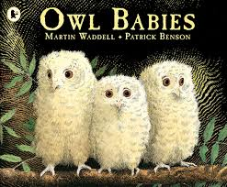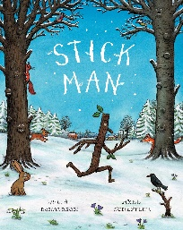

Reception
Autumn Term Overview
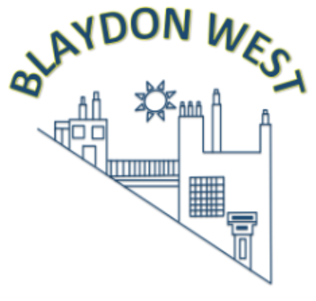
Our Themes:
Autumn 1 - Marvellous Me
Autumn 2 - Let’s Celebrate

Maths
Number
Children will represent, compose and compare numbers to 5.
Children will subitise to 5.

Numerical Patterns
Children will match and sort.
Children will compare amounts, size, mass and capacity.
Children will make AB patterns.
Children will identify and describe circles, triangles, squares and rectangles.
Children will use positional language including under, over, around and through.

Children will identify one more and one less within 5

Personal, Social and Emotional Development
Self-Regulation
Children will see themselves as unique by sharing their hobbies and interests.
Children will know how to be helpful by taking on jobs such as serving snack and washing up.
Managing Self
Children will know how regular exercise is important for their health.
Children will know the school rules.
Children will know how healthy eating is important for their health.
Building Relationships
Children will know how to identify their feelings, using books such as ‘The Colour Monster’ to support understanding.
Children will know how to listen to others with respect.

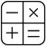

[
Expressive Arts and Design
Creating with Materials
Children will know how to mix primary colours to make secondary colours using poster paints. Children will know how to draw a person – head, body, arms, legs and facial features.
Children will know how to make the flange join and treasury tag join.
Children will know how to mold clay.
Children will make a bonfire night inspired piece of art - painting and collage.
Inspired by The Dot, children will produce artwork in the style of Kandinsky.
Children will learn a selection of nursery rhymes.

Understanding the World

Children will know how they have changed from being a baby to being 4/5.
Children will know that Remembrance Day is to remember soldiers who died in the war.
Children will identify typical weather in Autumn.
Children will know the names of body parts: shoulders, elbows, knees, ankles.
Children will know what material a magnet picks up.
Children will know that Blaydon is in England.

Physical Development
Gross Motor
Children will know how to hop, skip and jump.
Children will know how to use the pole.
Fine Motor
Children will know the correct pencil grip and posture for writing. Children will know how to do up and undo buttons.
Children will know how to correctly form the letters m,a,s,d, t, i, n, p, g, o.
Should you require any further information, please email -eyfs@blaydonwest.gateshead.sch.uk

